

THE HERITAGE

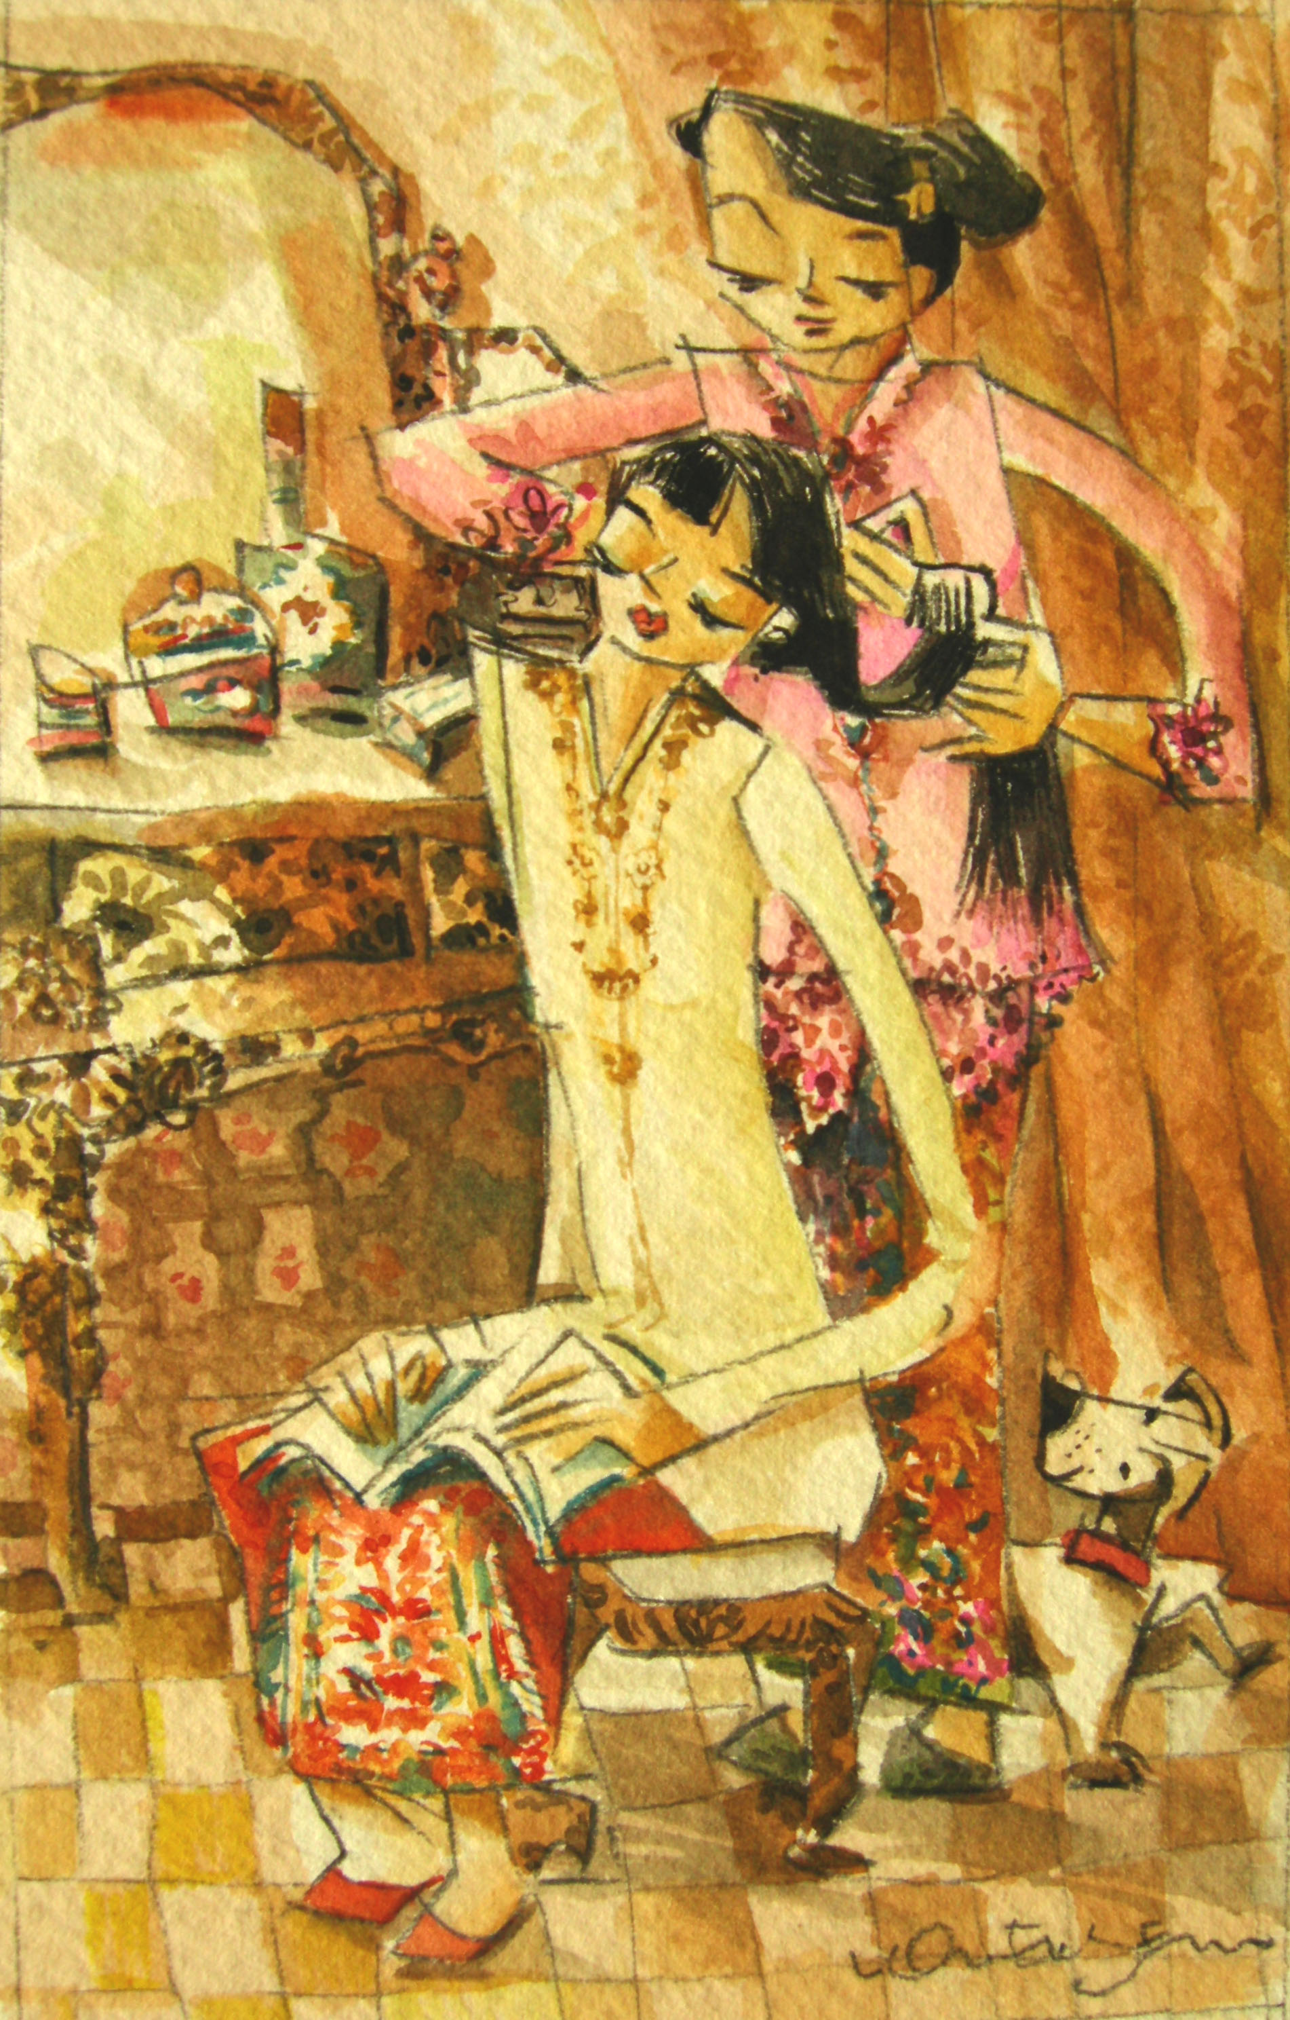
The Berandam
Two days before the wedding, at noon, the berandam-the ritual of combing and trimming the bride’s hair-takes place. The fringe is tied to tiny tufts at both sides of the forehead. The ribbon is either white (signifying the bride’s purity) or red (to commemorate the joyous occasion). The hairdresser is usually also the mistress of ceremonies for the wedding.

